# Project Development Phase Delivery of Sprint-2

|  |  |
| --- | --- |
| **Team ID :** | **PNT2022TMID47568** |
| **Project Name :** | **Analytics for Hospital Health-Care Data** |

1. **Data Explorations:**
   1. **Ward_Type for Ward_Facility_Code**
   2. **case_id by patient_id**
   3. **City_Code_Hospital by City_Code_Hospital**
   4. **City_Code_Hospital by Department**
   5. **Department compared to Hospital_region_code**
   6. **Ward_Facility_Code for City_Code_Patient hierarchy**
   7. **Ward_Type colored by Department sized by Department**
   8. **Type of Admission by Department colored by Department**
   9. **Visitors with Patient by Type of Admission**
   10. **Hospital_region_code for Hospital_region_code regions**

**1.Ward_Type for Ward_Facility_Code**

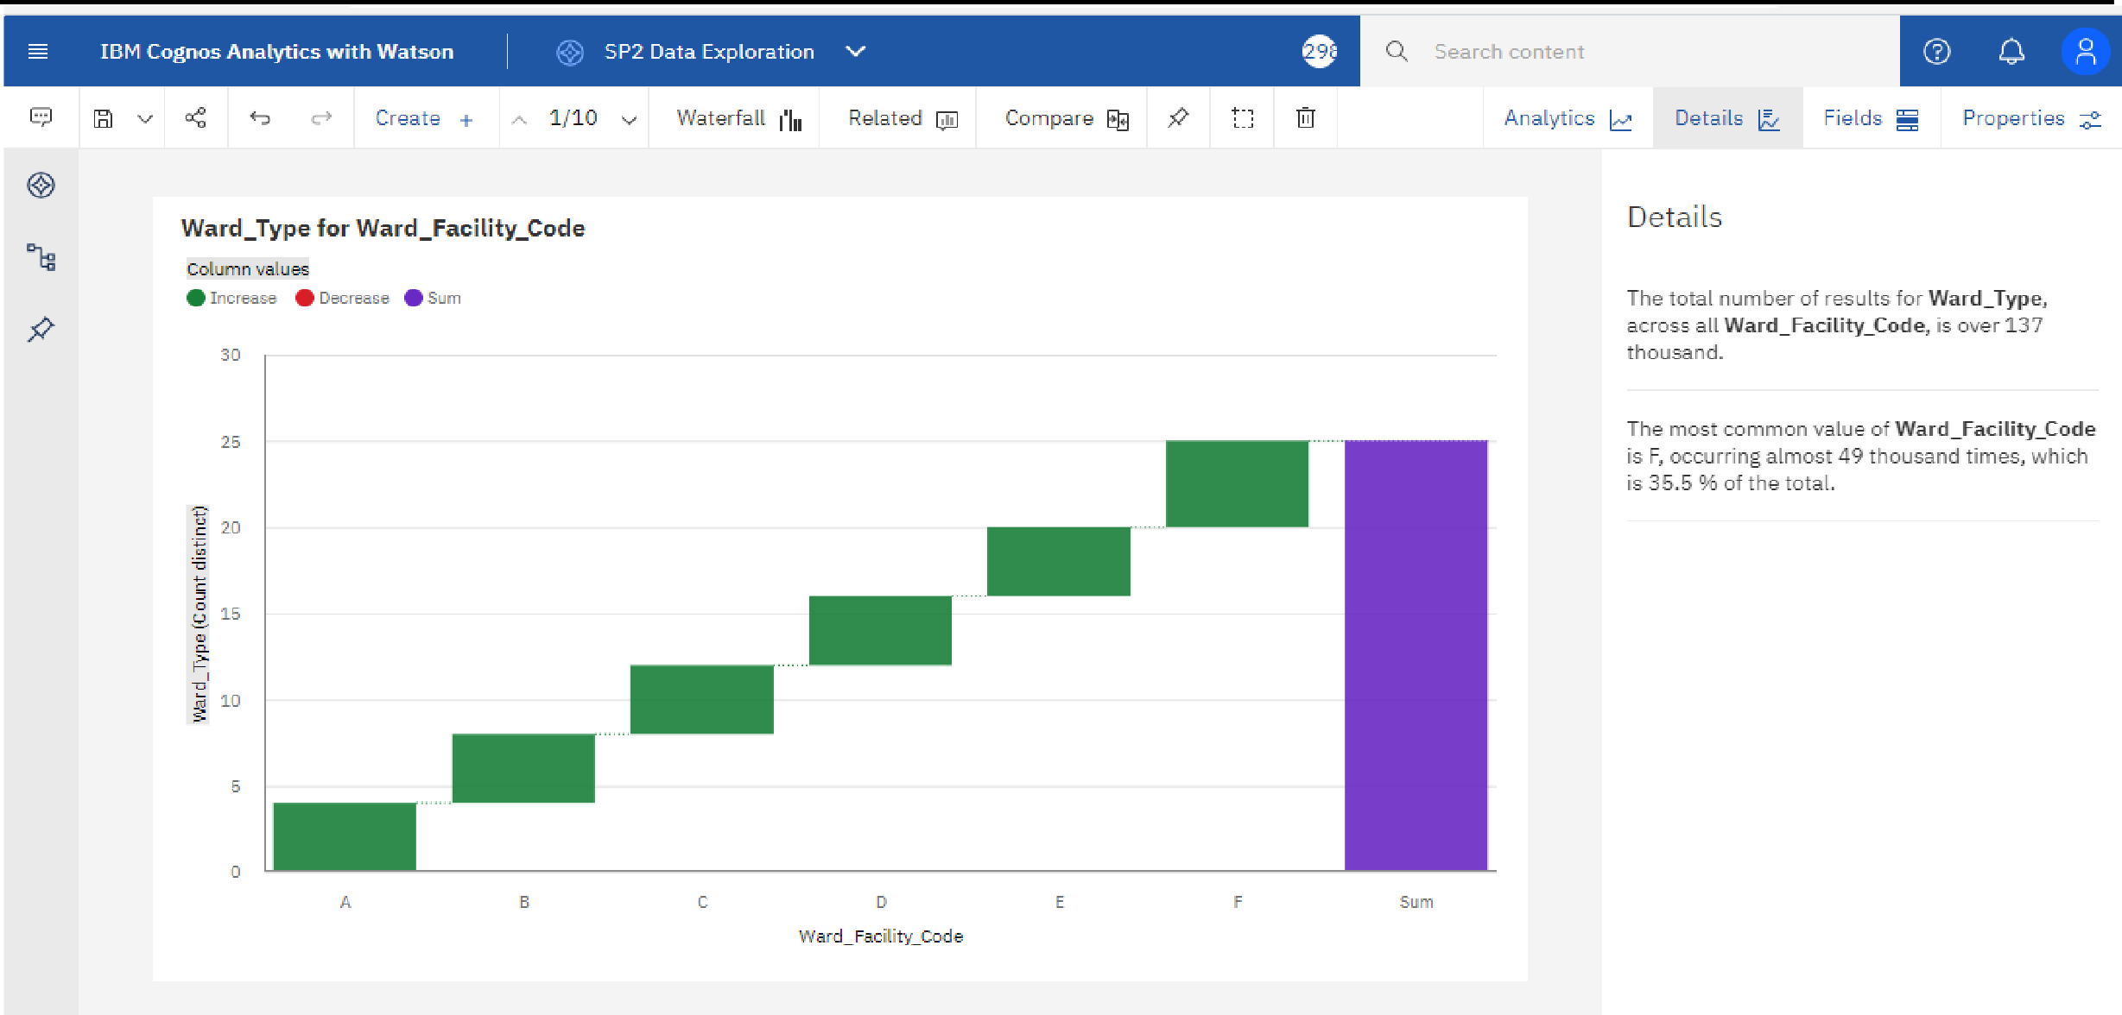

**2.case_id by patient_id**

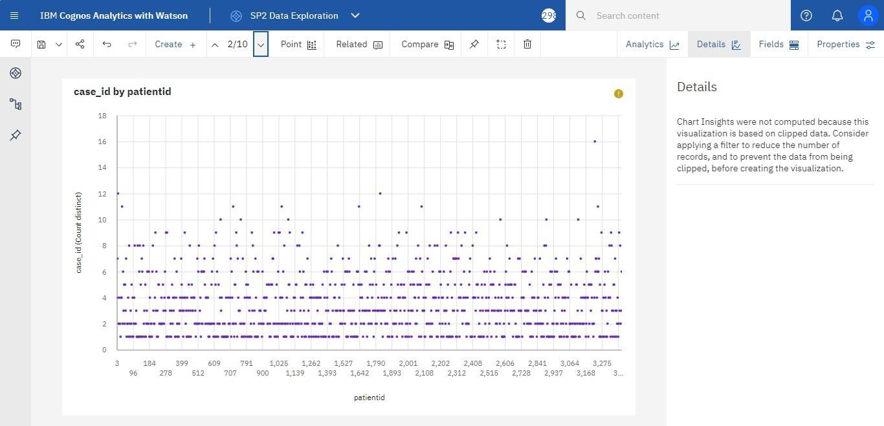

**3.City_Code_Hospital by City_Code_Hospital**

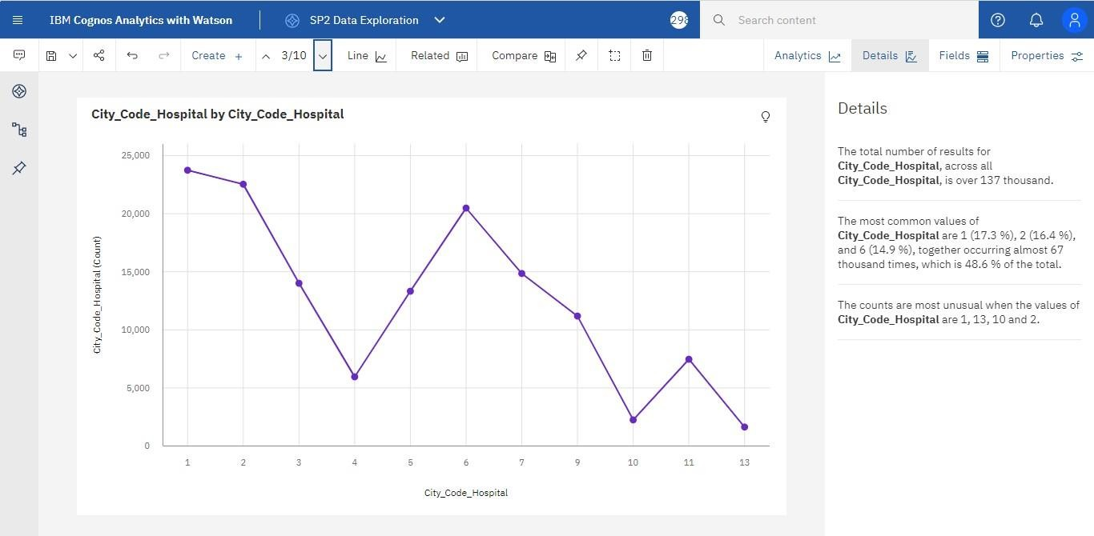

**4.City_Code_Hospital by Department**

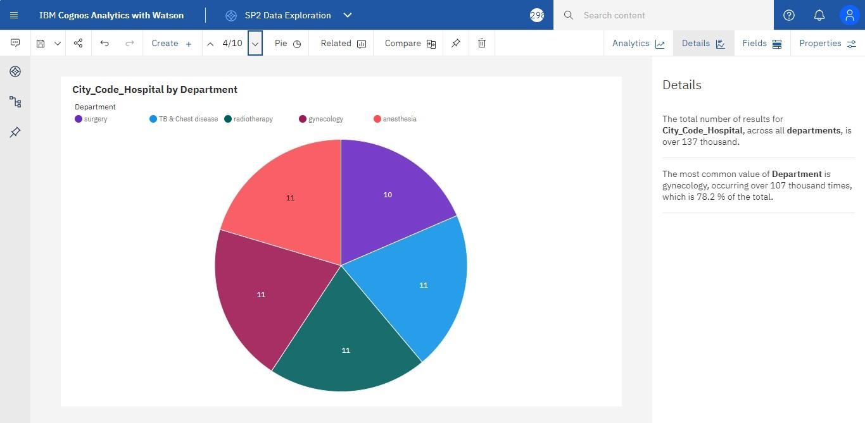

**5.Department compared to Hospital_region_code**

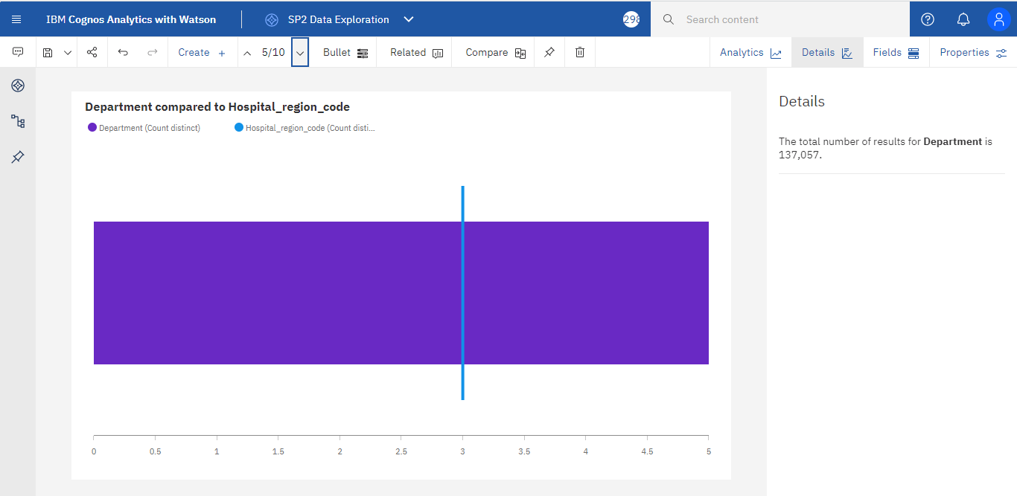

**6.Ward_Facility_Code for City_Code_Patient hierarchy**

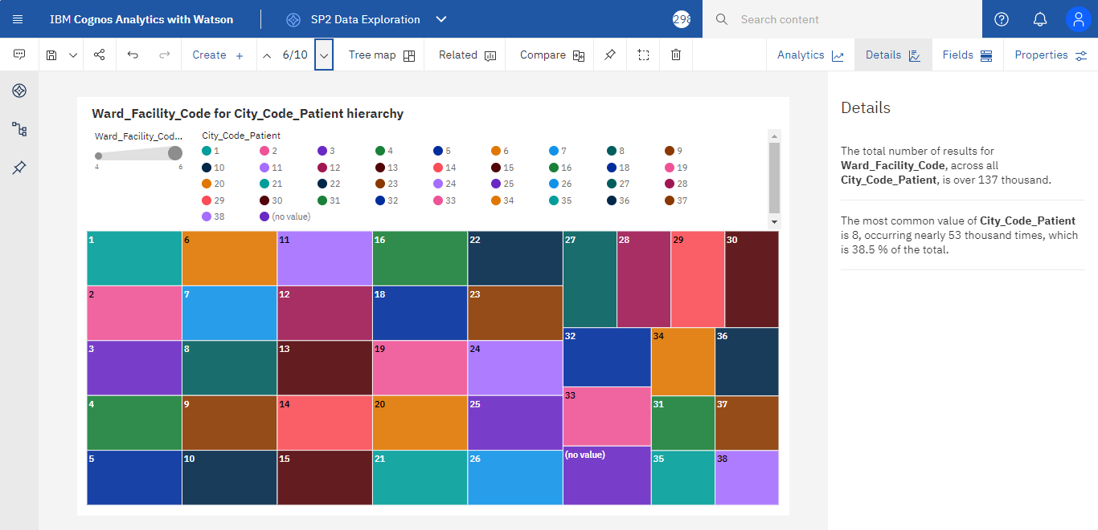

**7.Ward_Type colored by Department sized by Department**

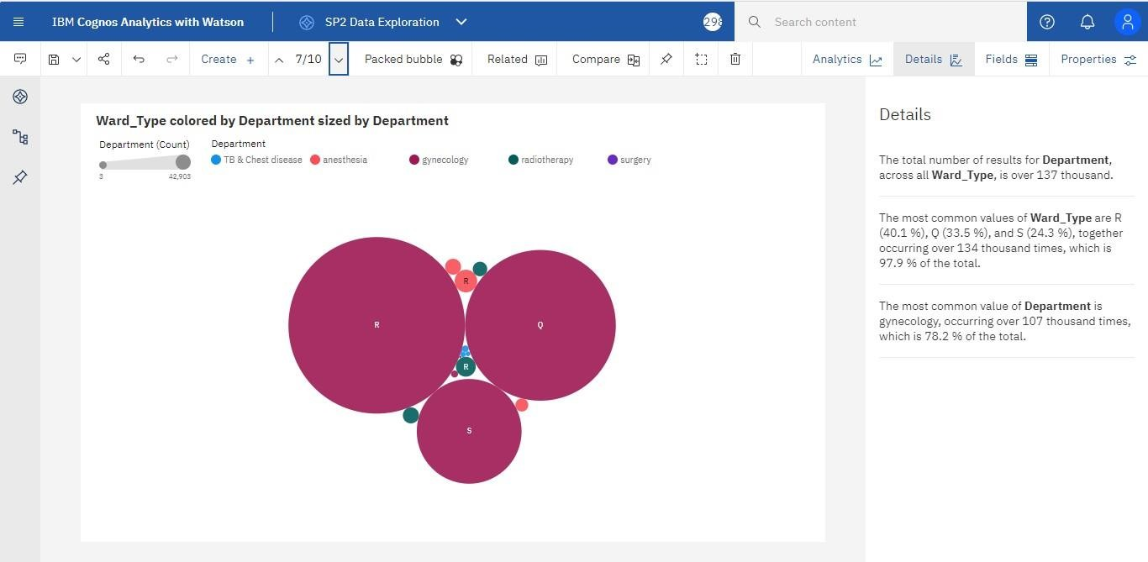

**8.Type of Admission by Department colored by Department**

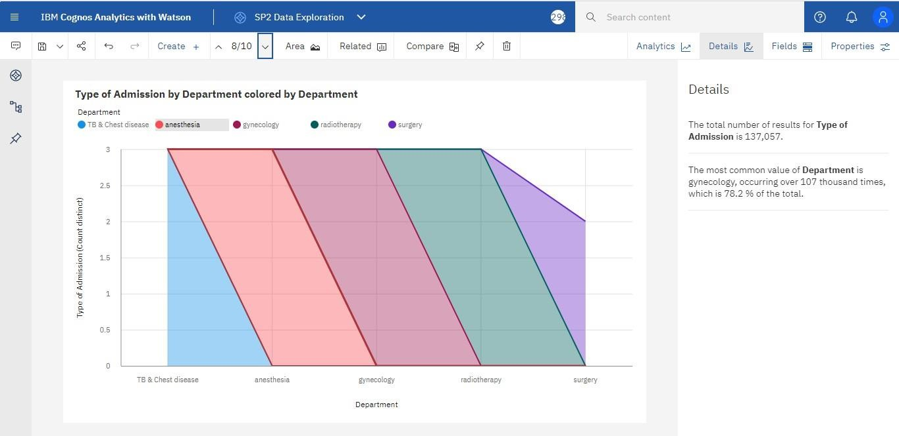

**9.Visitors with Patient by Type of Admission**

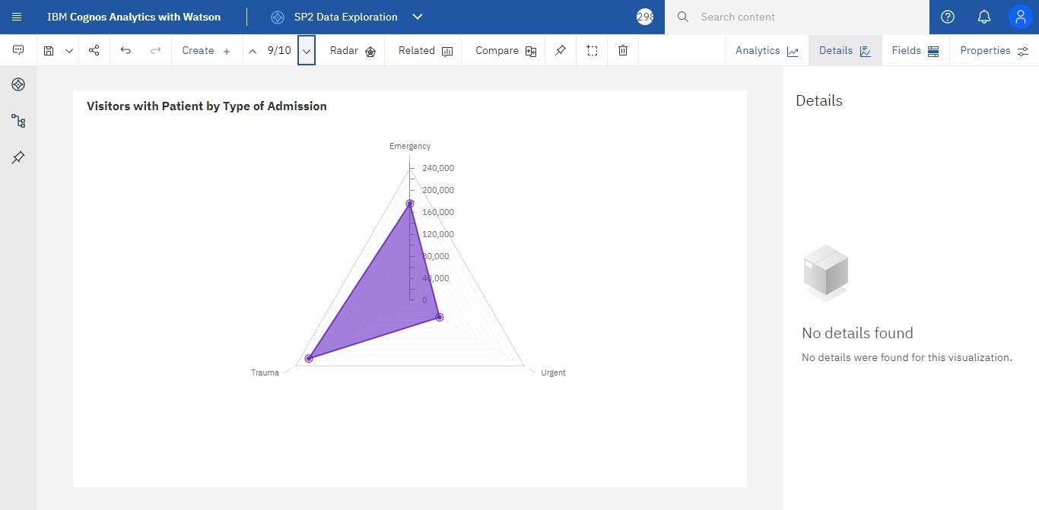

**10.Hospital_region_code for Hospital_region_code regions**

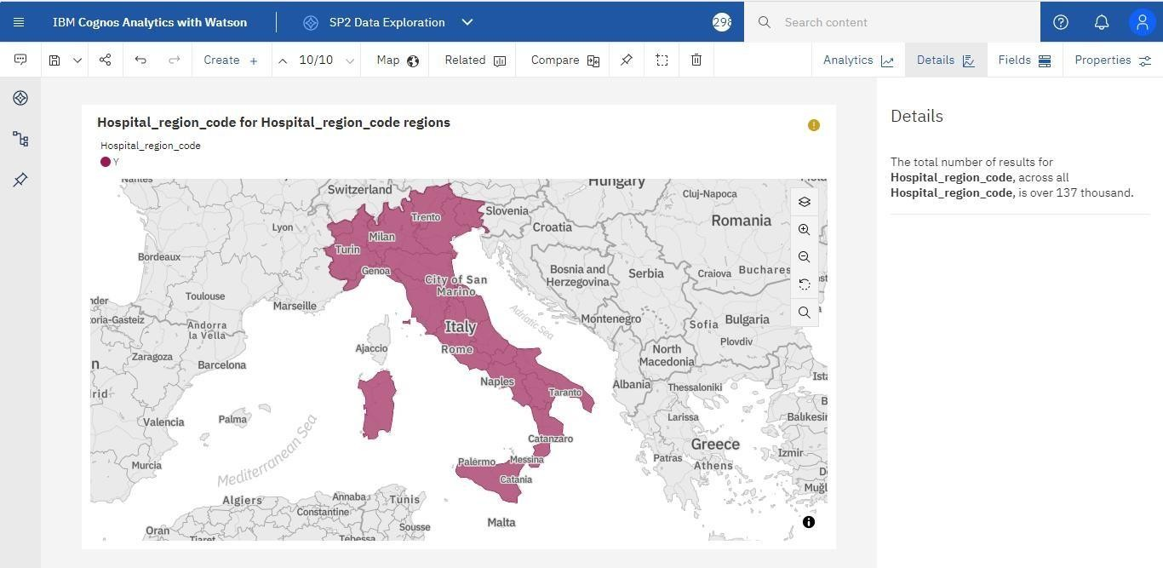

# Data Visualizations

* 1. **Number Of Patients By Ward Types**
  2. **Dashboard To Show Number Of Patients**
  3. **Age Wise Patients With Department And Severity Filters**
  4. **Dashboard With Hierarchy Bubble And Radial Visuals**
  5. **Dashboard Showing Pie, Stacked Bar, Waterfall And Pie Charts**

**1.Number Of Patients By Ward Types**

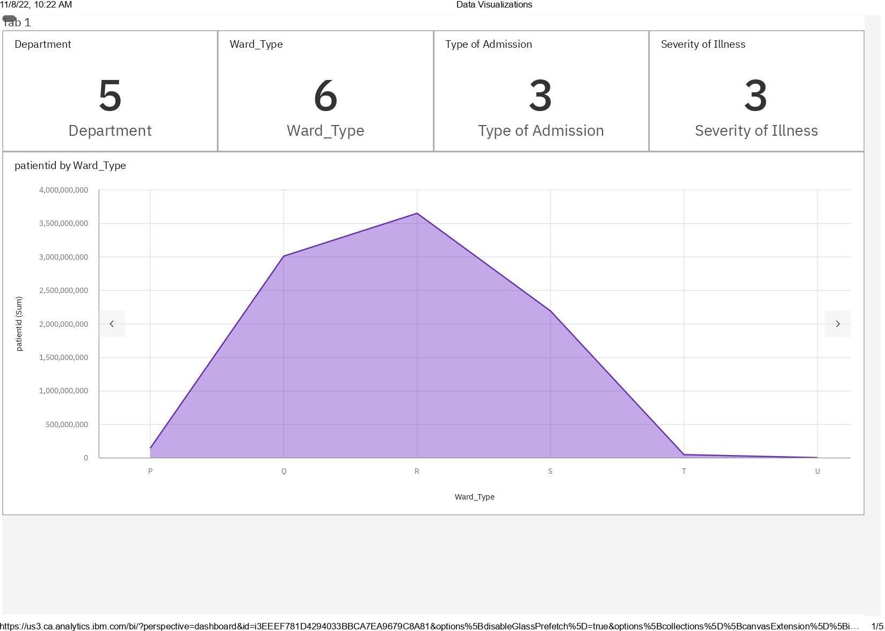

**2.Dashboard To Show Number Of Patients:**

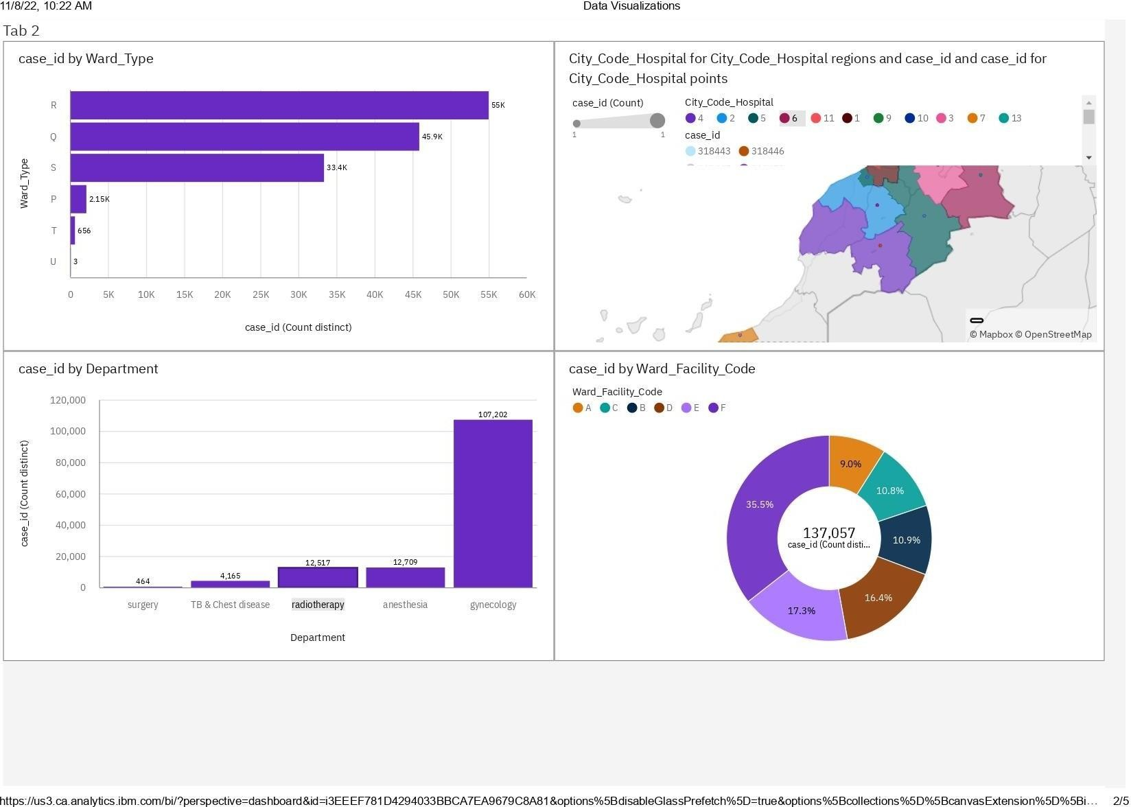

**3.Age Wise Patients With Department And Severity Filters**

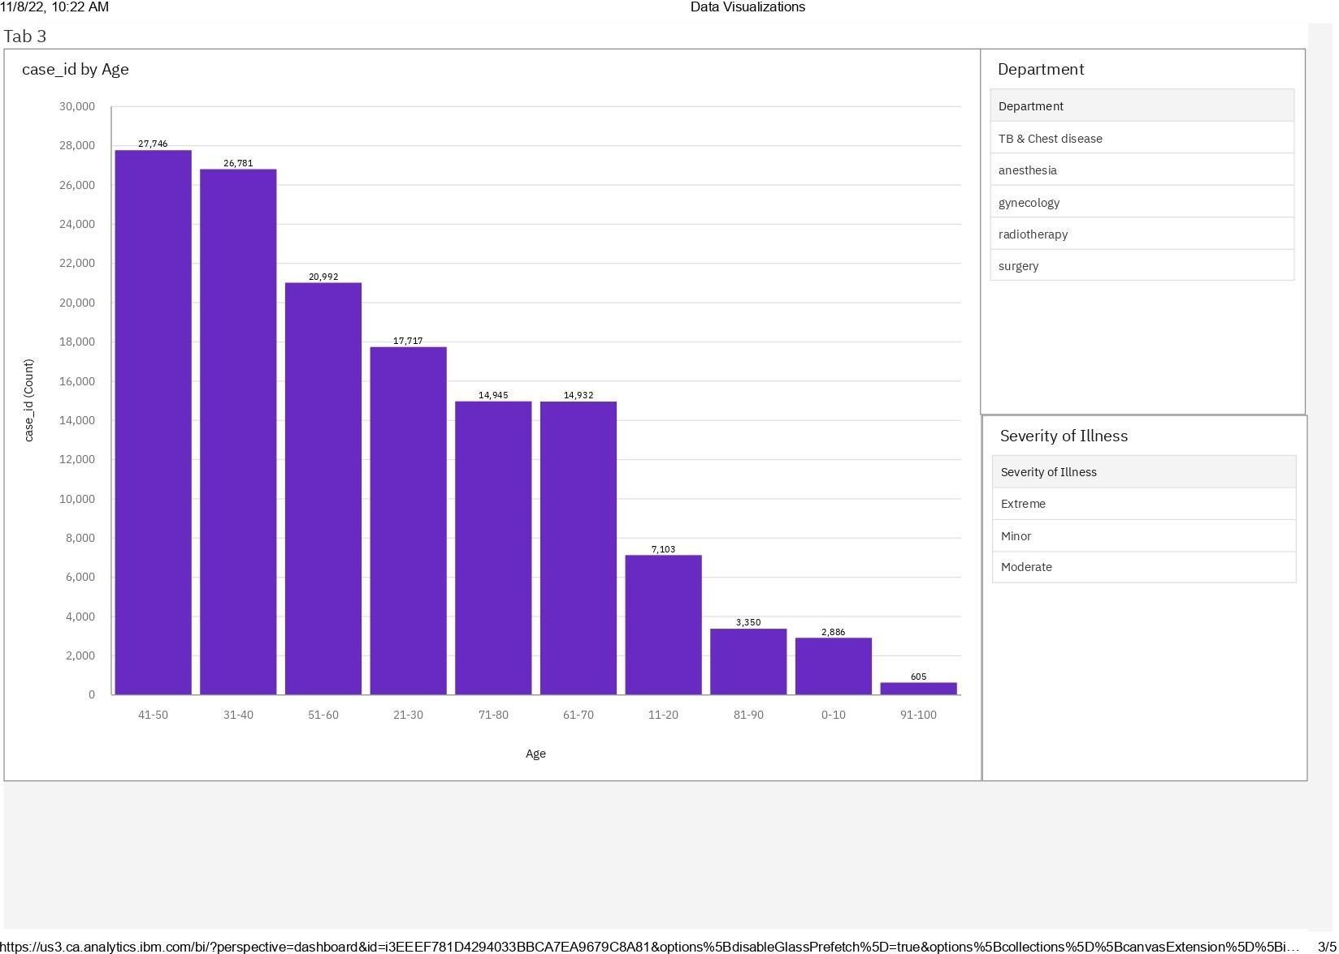

**4.Dashboard With Hierarchy Bubble And Radial Visuals**

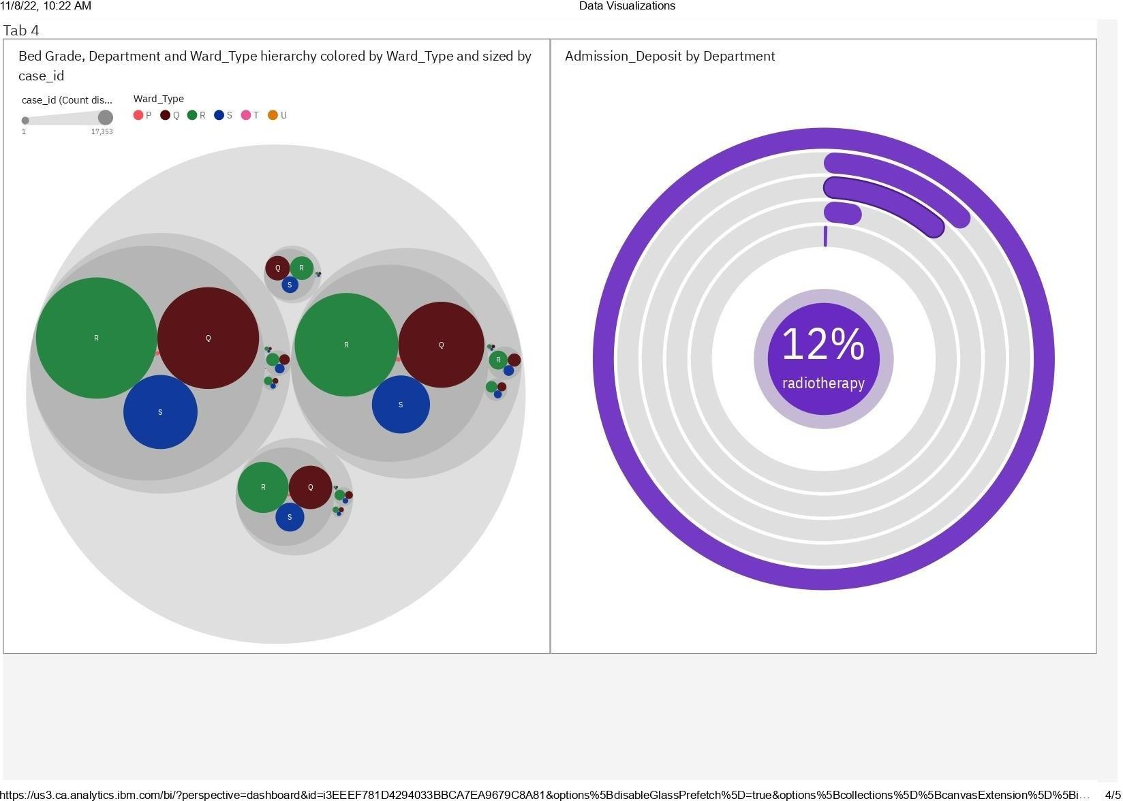

**5.Dashboard Showing Pie, Stacked Bar, Waterfall And Pie Charts**

